Name : C.Anukya Reddy
Roll No : 2303a52452
Batch No : 42
Task 1: AI-Generated Logic for Reading Consumer Details
Prompt:
Generate a Python program that reads Previous Units (PU), Current Units (CU), and Type of Customer from the user.
The program should calculate the units consumed and display all details.
Implement the logic directly in the main program without using functions.
CODE:
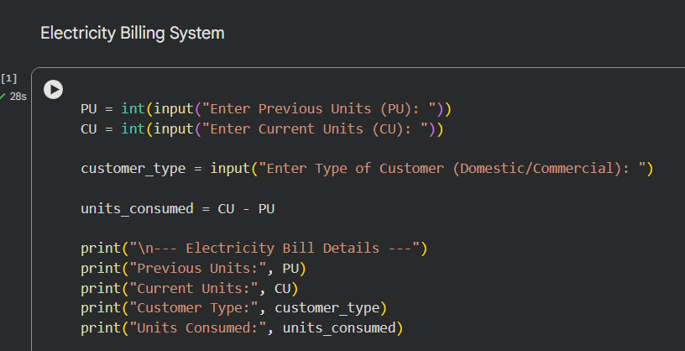
OUTPUT:
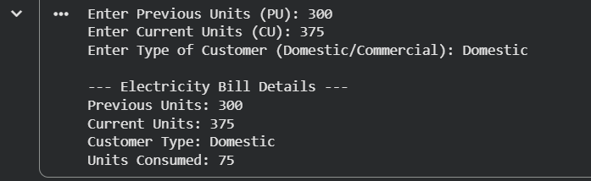
JUSTIFICATION:
The program reads the previous units, current units, and type of customer using input statements. It calculates the units consumed by subtracting the previous units from the current units. All the logic is written directly in the main program without using any functions, as required. The program clearly displays the consumer details and the calculated units, making it suitable for an electricity billing system.

Task 2: Energy Charges Calculation Based on Units Consumed
Prompt
Generate a Python program for an electricity billing system that reads previous units, current units, and customer type.
Calculate the units consumed and determine energy charges based on domestic, commercial, or industrial categories.
Use clear and optimized conditional statements for applying different tariff rates.
Implement all logic directly in the main program and display the billing details clearly.
CODE:
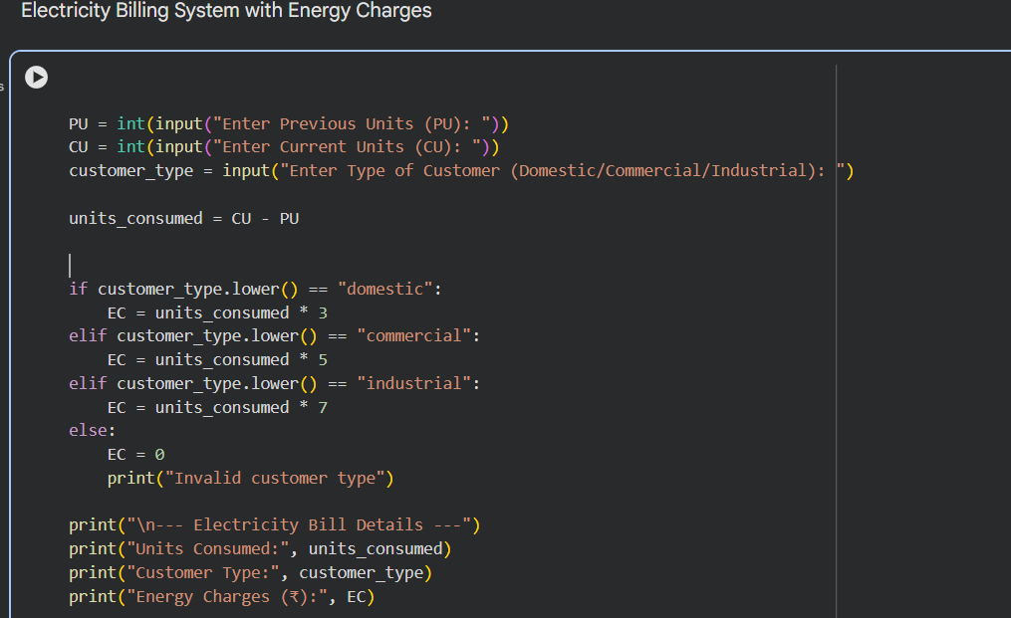
OUTPUT:
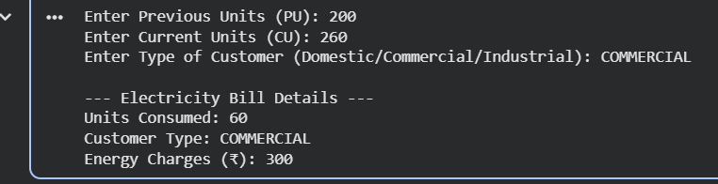
JUSTIFICATION:
The program calculates energy charges based on units consumed and the type of customer using conditional statements. Different tariff rates are applied for domestic, commercial, and industrial consumers to ensure accurate billing. The logic is implemented directly in the main program without using functions, as required. The optimized conditions improve readability and make the billing system clear and efficient
Task 3: Modular Design Using AI Assistance (Using Functions)
PROMPT:
Generate a Python program for an electricity billing system using user-defined functions.
Create separate functions to calculate Energy Charges and Fixed Charges based on units consumed and customer type.
Each function should return the calculated value and include meaningful comments for clarity.
Display the final billing details in the main program.
CODE:
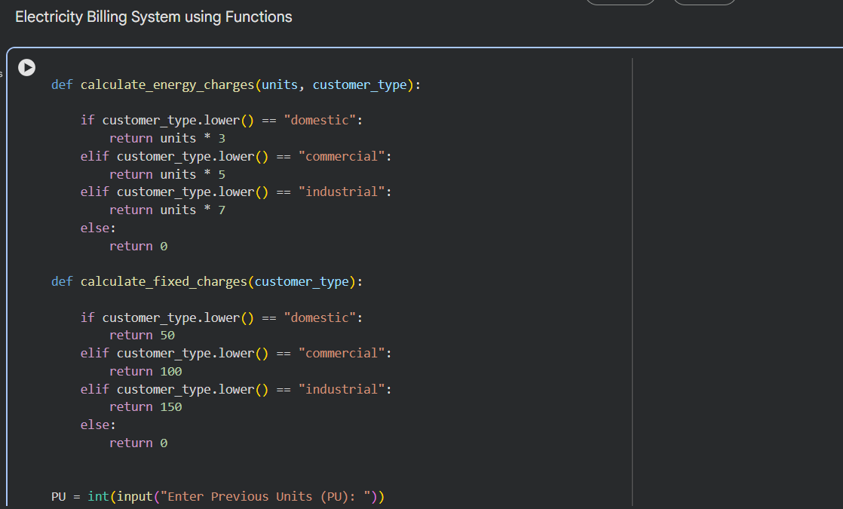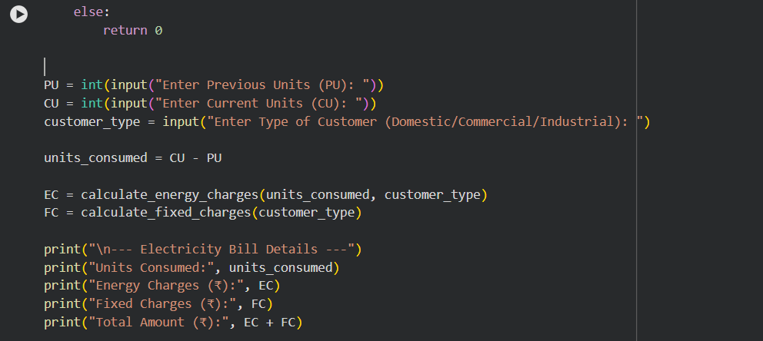
OUTPUT:
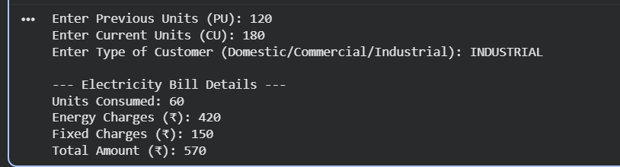
JUSTIFICATION:
The program uses user-defined functions to calculate energy charges and fixed charges, making the billing logic modular and reusable. Each function returns calculated values, improving clarity and maintainability of the code. Meaningful comments are included to explain the purpose of each function. This modular design allows easy extension of the billing system for multiple consumers.
Task 4: Calculation of Additional Charges
PROMPT:
Generate a Python program that extends an electricity billing system to calculate Fixed Charges, Customer Charges, and Electricity Duty.
Electricity Duty should be calculated as a percentage of the Energy Charges.
Display each charge separately with a clear and structured output.
Ensure billing accuracy by verifying and printing all intermediate charge values.

CODE:
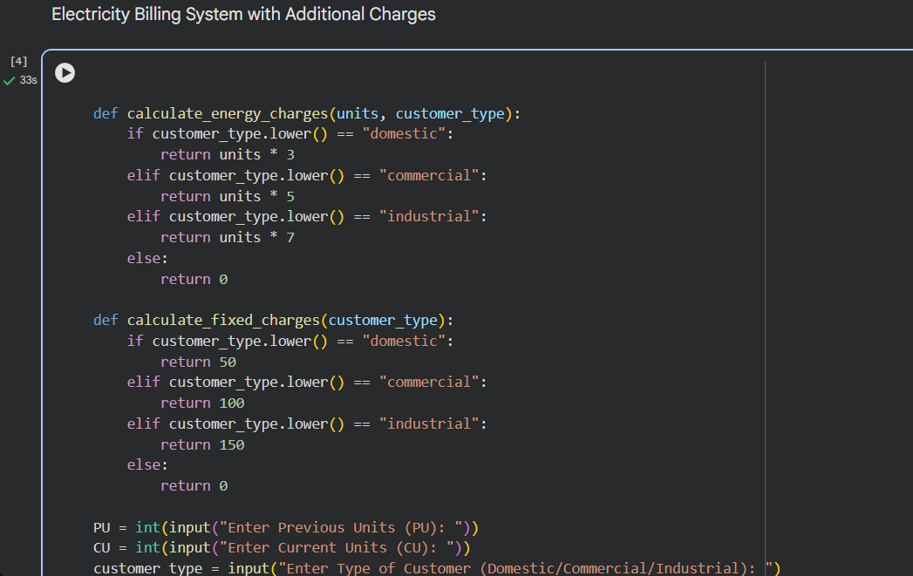
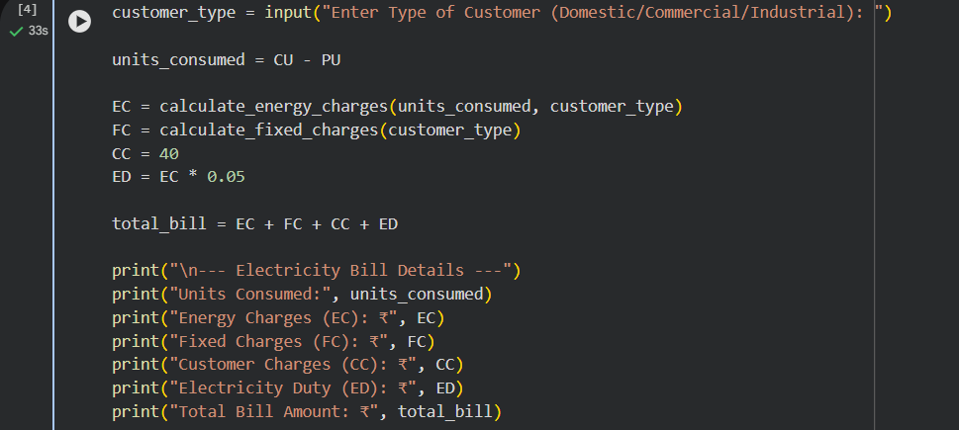
OUTPUT:
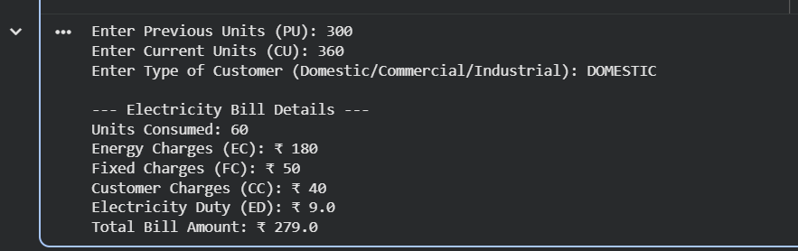
JUSTIFICATION:
The program accurately calculates additional billing components such as fixed charges, customer charges, and electricity duty. Electricity duty is computed as a percentage of energy charges to improve billing accuracy. Each charge is displayed separately to verify intermediate results clearly. The structured output ensures transparency and correctness in electricity bill generation.
Task 5: Final Bill Generation and Output Analysis
PROMPT:
Generate a complete Python program to calculate and display the final electricity bill.
The program should compute Energy Charges, Fixed Charges, Customer Charges, and Electricity Duty, and then calculate the total bill amount.
Display all values clearly in a neatly formatted output suitable for real-world billing.
CODE:
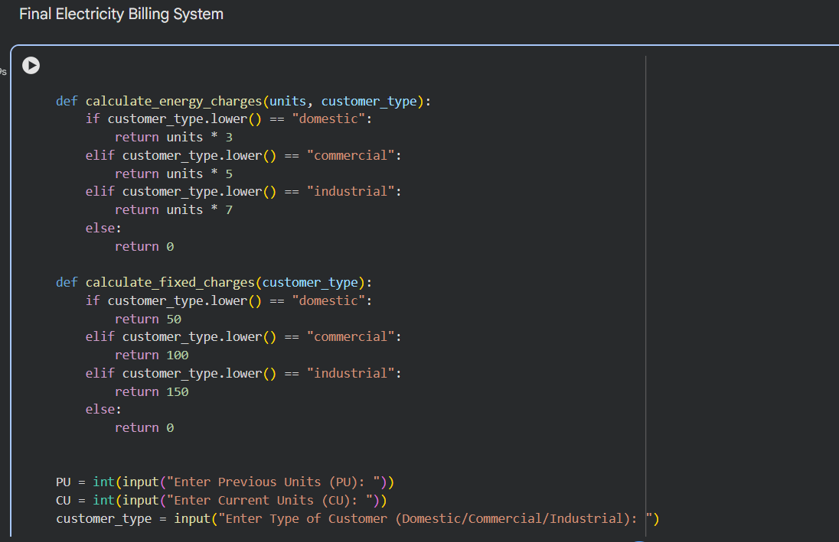
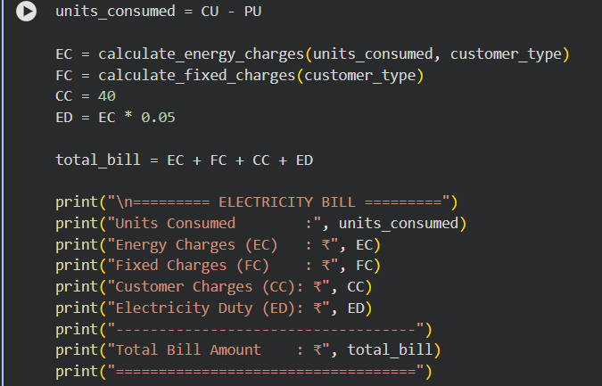
OUTPUT:
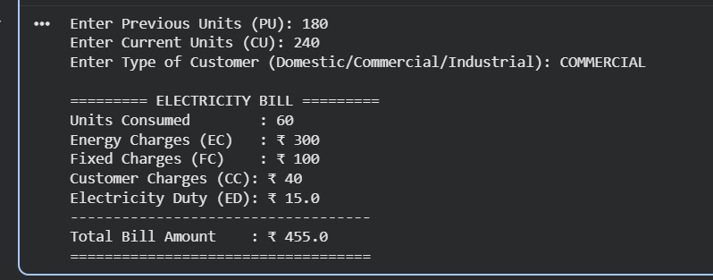
JUSTIFICATION:
The program calculates the total electricity bill by summing energy charges, fixed charges, customer charges, and electricity duty. Each charge is displayed separately to ensure transparency and correctness. Modular design improves clarity and maintainability of the code. The final output is neatly formatted for real-world bill presentation.

